***A Major Project report on***

**UAV FOR LANDMINE DETECTION**

*submitted in partial fulfillment*

*of the Academic requirements for*

*the award of degree of*

**BACHELOR OF TECHNOLOGY**

IN

**Mechanical Engineering**

Submitted by

**B JAGAPATHI BABU 17H51A0367**

**K ESHWARTEJA 17H51A0381**

**MOHANA KRISHNA K 17H51A0397**

**V SUDEEP 17H51A03B2**

Under the guidance of

**Dr. K. Srinivasa Rao**

**Professor**



**Department of Mechanical Engineering**

**CMR COLLEGE OF ENGINEERING & TECHNOLOGY**

(Approved by AICTE, New Delhi, Affiliated to JNTU, Hyderabad)

**Department of Mechanical Engineering**

**CMR COLLEGE OF ENGINEERING & TECHNOLOGY**

(Approved by AICTE, New Delhi, Affiliated to JNTU, Hyderabad)

KANDLAKOYA (V) MEDCHAL ROAD, HYDERABAD-501401

2017-2021



**CERTIFICATE**

This is to certify that, the project entitled **“UAV FOR LAND MINE DETECTION**” is a bonafide work done by has **B.JAGAPATHI BABU (17H51A0367), K.ESHWARTEJA (17H51A0381), MOHANA KRISHNA K (17H51A0397), V.SUDEEP (17H51A03B2) of** IVth year B.Tech, Mechanical engineering in partial fulfillment of the requirements for the award of the **BACHELOR OF TECHNOLOGY** in **MECHANICAL ENGINEERING**, submitted to the Department of Mechanical engineering, CMR college of engineering & technology, Hyderabad during the Academic Year 2020-2021. The result embodied in this project report has not been submitted to any other university or Institute for the award of any degree.

Internal guide Head of the Department

Dr.K.Srinivasa Rao Dr.P.Ravi kumar

Professor Professor

**DECLARATION**

We, the students of IVth B.Tech, Department of Mechanical Engineering**, CMR COLLEGE** **OF ENGINEERING & TECHNOLOGY**, Kandlakoya, Hyderabad, hereby declare, that under the supervision of our guide Professor **Dr.K.Srinivasa Rao** we have carried out the project titled “**UAV FOR LANDMINE DETECTION**” and submitted the report in partial fulfillment of requirement for the award of Bachelor of Technology In Mechanical Engineering by Jawaharlal Nehru Technological University(JNTUH) during the academic year 2017-2021.

**B JAGAPATHIBABU 17H51A0367**

**K ESHWARTEJA 17H51A0381**

**MOHANA KRISHNA K 17H51A0397**

**V SUDEEP 17H51A03B2**

Date:

Place: Hyderabad

**ACKNOWLEDGEMENT**

With the great pleasure we want to take this opportunity to express our heartfelt gratitude to all the people who helped in making this project work to grand success.

We extend our sincere and deep sense of gratitude, pleasure, gratefulness and indebtedness to acknowledge of **Dr.K.Srinivasa Rao, Professor, DEPARTMENT OF** **MECHANICAL ENGINEERING,** for his unstained support, guidance and for keen interest evinced cooperation at all stages of our project.

We are obliged and grateful to thank **Mr.P.RAVIKUMAR, HEAD OF THE DEPARTMENT, MECHANICAL ENGINEERING, f**or his cooperation in all aspects in the course of this project work.

Our sincere thanks to **Major Dr.V.A.NARAYANA, PRINCIPAL, CMR COLLEGE OF ENGINEERING & TECHNOLOGY,** Hyderabad for providing all the necessary facilities to complete this dissertation.

We express our sincere thanks to Sri **CH.GOPAL REDDY Garu, SECRETARY,CMR COLLEGE OF ENGINEERING & TECHNOLOGY**, for his continuous care towards our achievements.

Finally,we would like to thank the teaching and non teaching staff of Mechanical Engineering Department for sharing their knowledge with us throughout the course.

Ultimately, we own all our success to our beloved parents, whose vision, love and inspiration has made us to reach out for these glories.

**LIST OF CONTENTS**

**Page No**

**ABSTRACT** **1**

**CHAPTER 1 INTRODUCTION** **2-4**

1.1 Introduction 2

1.2 Aim Of The Project 2

1.3 Objectives 2

1.4 Literature Survey 3

**CHAPTER 2 DRONE** **5-13**

2.1 Drone or UAV 5

2.2 Types Of Drones 5

2.2.1 Multi Rotor Drone 6

2.2.2 Fixed Wing Drone 7

2.2.3 Single Rotor Helicopter 8

2.2.4 Fixed Wing Hybrid VTOL 9

2.3 Drone Uses 10

**CHAPTER 3 QUADCOPTER DRONE**  **14-18**

3.1 Introduction of Quadcopter Drone 14

3.2 Background 16

3.3 Quadcopter Dynamics 17

3.4 Advantages Of Quadcopter 17

3.5 Specifications and Goals 18

**CHAPTER 4 QUADCOPTER MATERIALS** **19-37**

4.1 Frame 19

4.1.1 Purpose of choosing 20

4.1.2 Quadcopter frame types 21

4.2 DC Brushless Motor 23

4.2.1 BLDC Motor 25

4.2.2 Brushless vs Brushed motors 25

4.2.3 Applications 27

4.3 Electronic Speed Control 29

4.4 Propeller 32

4.4.1 Requirements 34

4.4.2 Alternatives 34

4.4.3 Decision criteria 34

4.4.4 Decision 34

4.5 LI-PO Battery 35

4.6 Remote Control 37

**CHAPTER 5 Mechanics of Drone 38-41**

5.1 Material Composition 38

5.2 Motion 38

**CHAPTER 6 Metal Detector 42-51**

6.1 Introduction 42

6.2 Brief history of Metal Detector 43

6.3 Principle of Metal Detector 43

6.3.1 Circuit Diagram 44

6.4 Metal Detector circuit 45

6.4.1 Working of the circuit46

**CHAPTER 7 Landmine Detection Drone 51-53**

**CHAPTER 8 Stages of fabrication 54-55**

**CHAPTER 9 Result 56-59**

9.1 Fabrication 59

**CHAPTER 10 Conclusion 60**

**REFERENCES 61-62**

**List of Figures**

**S.NO Figure Details Page No**

Fig 2.1 Different types of drones 5

Fig 2.2 Multi Rotor Drone 6

Fig2.3 Fixed Wing Drone 7

Fig 2.4 Single Rotor Drone 8

Fig 2.5 Fixed Wing Hybrid VTOL 9

Fig 2.6 Military Drone 10

Fig 2.7 Agriculture Drone 11

Fig 2.8 Delivery Drone 11

Fig 3.1 Quadcopter Drone 14

Fig 3.2 Block Diagram of UAV 15

Fig 4.1 Frame 19

Fig 4.2 Brushless Motor 23

Fig 4.3 Electronic speed Control ESC) 30

Fig 4.4 Propellers 33

Fig 4.5 LI-PO Battery 34

Fig 4.6 Remote Controller 36

Fig 5.1 Movement of drone 38

Fig 5.2 Turning 39

Fig 5.3 Forwards and Sideways of Drone 40

Fig 5.4 Drone 40

Fig 6.1 Anatomy of Metal Detector 42

Fig 6.2 Circuit Diagram of Metal Detector 44

Fig 6.3 Block Diagram of Metal Detector 45

Fig 6.4 Detecting of Materials of Different Depths 48

Fig 7.1 Landmine Detecting Drone 51

Fig 9.1 Graph obtained from test results 58

**LIST OF TABLES**

**S.no Table details Page no**

Table-1 Accuracy of metal detector with varying altitude 57

when parts not buried

Table-2 Accuracy of metal detector with varying altitude 59

when parts buried

**ABSTRACT**

Explosive landmines have cost the lives of hundreds in several countries. Our projects presents a field report of a low cost unmanned aerial vehicle AR drone used as a complemented tool for landmine detection in rural scenarios. The main contribution of this work is the practical experimentation with an integrated tool. This tool is composed by the AR drone quadrotor and a base station for monitoring the mission. Experiments have been carried out to quantify the performance of the platform by means of measuring the percentage of the detection at different set of flight speeds and altitudes. The goal is not only to detect fully visible landmines but also those partially buried. It has been observed an effective percentage of the detection over 80%, when flying at low altitudes about 1m from the ground at speeds up to 2.2 ms-1.The visual methods introduced here in might enable the ARdrone quadrotor to be used as a low-cost autonomous platform for safe area coverage applied to landmine detection in real scenarios.

**CHAPTER -1**

**1.1 INTRODUCTION** :

Explosive landmines represent one of the most risky issues for people that live in conflict areas. The military has been the first to deploy machines as an attempt to overcome the risks involved when the landmine detection process is carried out by humans. Currently, there are fully autonomous systems which do not require a human operator for monitoring both detection and deactivation of explosive landmines, however these systems are highly expensive and also require qualified personnel .

**1.2 AIM OF THE PROJECT:**

Mine detection using a surveillance drone is a modern conceptual prototype, which has been designed to detect landmines. Landmines were primarily used to create defensive and tactical barriers during the Second World War. They are still very much employed in large quantities in countries such as Afghanistan, Korea. A lot of these land mines still go undetected, increasing the death rate and creating havoc on the surroundings. The prototype developed helps us to detect a landmine using a flying drone. The prototype has a quad copter which has a mine detector mounted on it. This utilizes two different modes of detection, . These are extensively used in aiding this whole operation.There is a lot of untapped potential and scope of improvement for this prototype in the future. In this paper, we have successfully worked on a mine detector that performs functions of vested interest towards the military and commercial organizations.

**1.3 OBJECTIVES:**

The objective of explosives detection equipment is to detect certain types and amounts of explosive material with a high detection rate, a low false alarm rate. Our goal in this project is to integrate and evaluate a set of low cost technologies that allow the detection of explosive landmines autonomously and without compromising the mission. The goal is not only to detect fully visible landmines but also those partially buried. It has been observed an effective percentage of the detection over 80% when flying at low altitudes about 1m from the ground at speeds up to2.2m/sec. A metal detecting sensor is placed at the bottom of the quad copter drone to detect the metal specimen present on the ground. When an amount of metal is identified by sensor, it is designed to produce a sound to alert the surroundings and a camera which is attached to the drone helps us to detect the material with greater ease.

**1.4 LITERATURE REVIEW:**

Manuel Ricardo et al. [1] presented an approach for explosive-landmine detection on-board an autonomous aerial drone.They analysed the design, implementation and integration of a ground penetrating radar (GPR) using a software defined radio (SDR) platform into the aerial drone.Ground-penetrating radar (GPR) technique is successfully deployed with the aim of addressing important sensing problems that requires detection, imaging and identification of dielectric material discontinuities in the subsurface through the use of radio waves, providing a non-invasive method to probe the ground.

Castiblanco et al. [2] presented a field report of a low cost unmanned aerial vehicle -ARdrone 2.0- used as a complemented tool for landmine visual detection in rural scenarios.The main aim of this work is the practical experimentation with an integrated tool. This tool is composed by the ARdrone quadrotor and a base station for monitoring the mission. Based on visual feedback from the onboard camera, algorithms for landmine detection are applied. Experiments have been carried out to quantify the performance of the platform by means of measuring the percentage of the detection at different set of flight speeds and altitudes.It has been observed an effective percentage of the detection over 80%, when flying at low altitudes about 1m from the ground at speeds up to 2.2 m/s.

Aashish Raj et al. [3] studied the application of the concept of swarm robotics for the purpose of landmine detection. Swarm robotics is the technique where multiple robots are operating parallel in a synchronous manner to attain a common objective. In this project they used pure concept of swarm robotics with help of autobots, which are able to carry out the given task with the help of other bots. As per the concept of auto-bot here they used a UAV, which is able to sense the landmines in the warzones.

Rajesh Kannan Megalingam et al. [4] presented the research work of a simple bot to detect landmines and mark their locations using autonomous navigation using a simple Zumo32U4 robot. This light weight, autonomous wireless controlled robot which is capable of detecting the landmine at the depth of 5cm to 9cm under group.

Dr. Pran Kanai Saha et al. [5] studied an appropriate mathematical model for a machine and develop a complete control architecture which will allow the drone to fly. Using this features then to develop an UAV, for observation and scouting missions for civilian or even military personnel. AnUAV (Unmanned Aerial Vehicle) with precise payloads can hover straight above the fire zone to record video of the fire line, as well as thermal images that are then geo-tagged and communicated in real time to mobile command centers using the planning and monitoring system for firefighting.

**CHAPTER 2**

**DRONE**

**2 .1 DRONE (or) UAV:**

An unmanned aerial vehicle (UAV) or uncrewed aerial vehicle, commonly known as a drone, is an aircraft without any human pilot, crew or passengers on board. UAVs are a component of an unmanned aircraft system (UAS), which include additionally a ground-based controller and a system of communications with the UAV. The flight of UAVs may operate under remote control by a human operator, as remotely-piloted aircraft (RPA), or with various degrees of autonomy, such as autopilot assistance.

An Unmanned Aerial Vehicle (UAV) is defined as a "powered, aerial vehicle that does not carry a human operator, uses aerodynamic forces to provide vehicle lift, can fly autonomously or be piloted remotely, can be expendable or recoverable.”

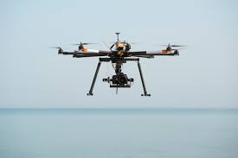 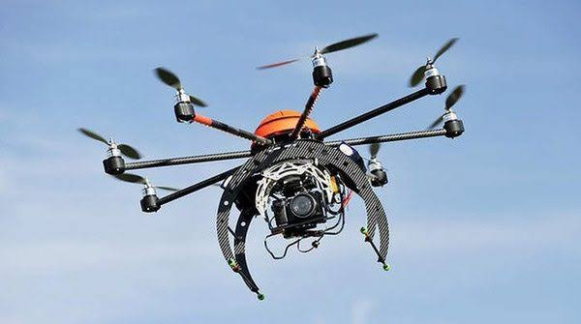

**Fig 2.1 Different type of drone**

**2.2 TYPES OF DRONES:**

Based on the type of aerial platform used , there are 4 major types of drones. They are :

* **2.2.1 MULTI ROTOR DRONES.**
* **2.2.2 FIXED WING DRONES.**
* **2.2.3 SINGLE ROTOR HELICPOPTER.**
* **2.2.4 FIXED WING HYBRID VTOL**

**2.2.1 MULTI ROTOR DRONES**:

Multi Rotor drones are the most common types of drones which are used by professionals. They are used for most common applications like aerial photography, aerial video surveillance etc. Different types of products are available in this segment in the market – say multi-rotor drones for professional uses like aerial photography. Out of all the 4 drone types (based on aerial platform), multi-rotor drones are the easiest to manufacture and they are the cheapest option available as well.

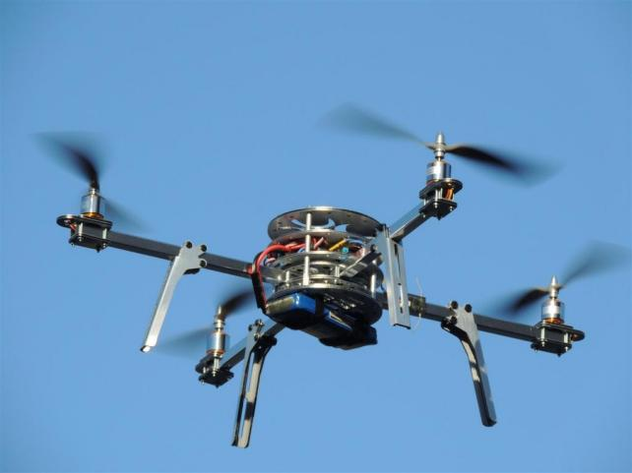

**Fig 2.2 Multi Rotor Drone**

Multi-rotor drones can be further classified based on the number of rotors on the platform. They are **Tricopter (3 rotors),** **Quadcopter (4 rotors),** **Hexacopter (6 rotors) and Octocopter (8 rotors).** Out of these, **Quadcopters are the most popular and widely used variant.**

Although easy to manufacture and relatively cheap, multi-rotor drones have many downsides. The prominent ones being it’s limited flying time, limited endurance and speed. They are not suitable for large-scale projects like long distance aerial mapping or surveillance. The fundamental problem with the multicopters is they have to spend a huge portion of their energy (possibly from a battery source) just to fight gravity and stabilize themselves in the air. At present, most of the multi- rotor drones out there are capable of only a 20 to 30 minutes flying time (often with a minimal payload like a camera).

**2.2.2 FIXED WING DRONES.**

Fixed Wing drones are entirely different in design and build to multi-rotor type drones. They use a ‘wing’ like the normal airplanes out there. Unlike multi-rotor drones, fixed wing type models never utilize energy to stay afloat on air (fixed wing types can’t stand still on the air) fighting gravity. Instead, they move forward on their set course or as set by the guide control (possibly a remote unit operated by a human) as long as their energy source permits.

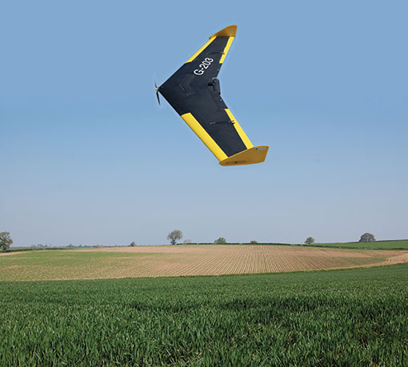

**Fig 2.3 Fixed Wing Drone**

Most fixed wing drones have an average flying time of a couple of hours. Gas engine powered drones can fly up to 16 hours or higher. Owing to their higher flying time and fuel efficiency, fixed wing drones are ideal for long distance operations (be it mapping or surveillance). But they can not be used for aerial photography where the drone needs to be kept still on the air for a period of time.

The other downsides of fixed-wing drones are higher costs & skill training required in flying. It’s not easy to put a fixed wing drone in the air. You either need a ‘runway’ or a catapult launcher to set a fixed wing drone on its course in the air. A runway or a parachute or a net is again necessary to land them back in ground safely. On the other side, **multi-rotor drones are cheap – anyone with a less investment to spare can buy a decent quadcopter.** Flying a quadcopter doesn’t require special training. You just take them to an open area and fly it. Guiding and controlling a quadcopter can be learned on the go.

**2.2.3 SINGLE ROTOR DRONES:**

Single rotor drones look very similar in design & structure to actual helicopters. Unlike a multi rotor drone, a single rotor model has just one big sized rotor plus a small sized one on the tail of the drone to control its heading. Single rotor drones are much efficient than multi rotor versions. They have higher flying times and can even be powered by gas engines. **In aerodynamics, the lower the count of rotors the lesser will be the spin of the object. And that’s the big reason why quadcopters are more stable than octocopters.** In that sense, single rotor drones are much efficient than multi-rotor drones.

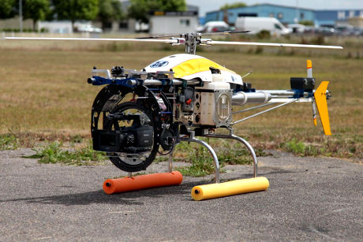

**Fig 2.4 Single Rotor Drone**

However, these machines comes with much higher complexity and operational risks. Their costs are also on the higher side. The large sized rotor blades often pose a risk if the drone is mishandled or involves in an accident. Multi-rotor drones, often owing to their small rotor blades have never been involved in fatal accidents (though a scar on human body is likely). They also demand special training to fly them on air properly (though they may not need a runway or a catapult launcher to put them on air).

**2.2.4 FIXED WING HYBRID VTOL:**

These are hybrid versions combining the benefits of Fixed wing models (higher flying time) with that of rotor based models (hover). This concept has been tested from around 1960’s without much success. However, with the advent of new generation sensors (gyros and accelerometers), this concept has got some new life and direction.

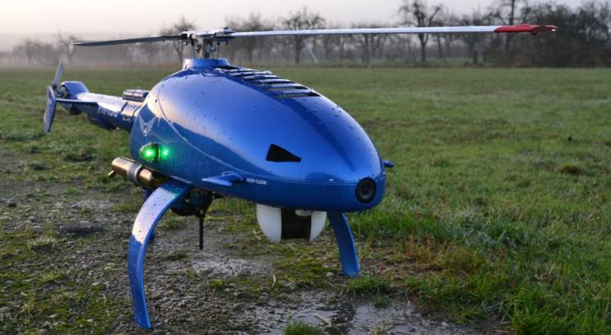

**Fig 2.5 Fixed Wing Hybrid VTOL**

Hybrid VTOL’s are a play of automation and manual gliding. A vertical lift is used to lift the drone up into the air from the ground. Gyros and accelerometers work in automated mode (autopilot concept) to keep the drone stabilized in the air. Remote based (or even programmed) manual control is used to guide the drone on the desired course.

There are some versions of this hybrid fixed wing models available in the market.However, the most popular one is drone used in amazon commercials (for its prime delivary services).

**2.3 DRONE USES:**

**MILITARY:**

Probably the oldest, most well-known and controversial use of drones is in the military. The British and U.S. militaries started using very basic forms of drones in the early 1940’s to spy on the Axis powers. Today’s drones are much more advanced than the UAVs of previous year, equipped with thermal imaging, laser range finders and even tools to perform airstrikes. The most prominent military drone in use today is the MQ-9 Reaper. The aircraft measures 36 feet long, can fly 50,000 feet in the air undetected and is equipped with a combination of missiles and intelligence gathering tools.

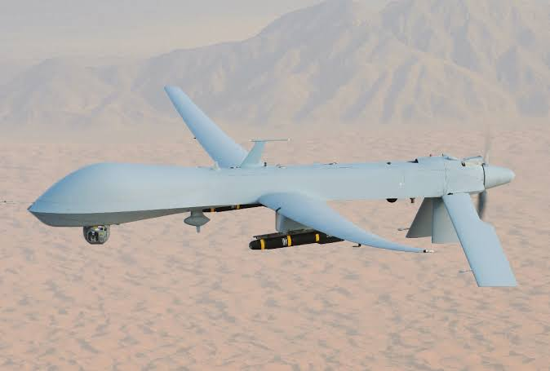

**Fig 2.6 Military Drone**

**AGRICULTURE DRONES:**

This types of drones are use in the field of agriculture. They help the farmers in spraying of pesticides in fields. An agricultural drone is an unmanned aerial vehicle used to help optimize agriculture operations, increase crop production, and monitor crop growth. Sensors and digital imaging capabilities can give farmers a richer picture of their fields. Using an agriculture drone and gathering information from it may prove useful in improving crop yields and farm efficiency. The aerial view provided by a drone can reveal many issues such as irrigation problems, soil variation, and pest and fungal infestations.

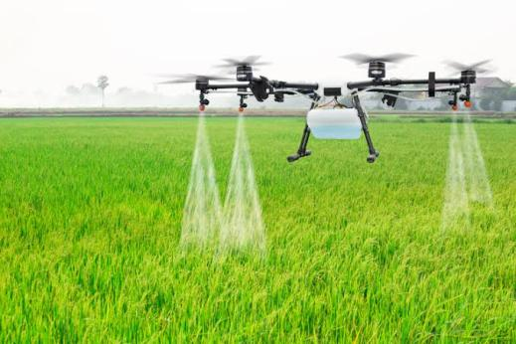

**Fig 2.7 Agriculture Drone**

Multispectral images show a near-infrared view as well as a visual spectrum view. The combination shows the farmer the differences between healthy and unhealthy plants, a difference not always clearly visible to the human eye. Thus, these views can assist in assessing crop growth and production. Crops can be surveyed at any time using agricultural drones, allowing for rapid identification of problems.

**DELIVERY DRONES:**

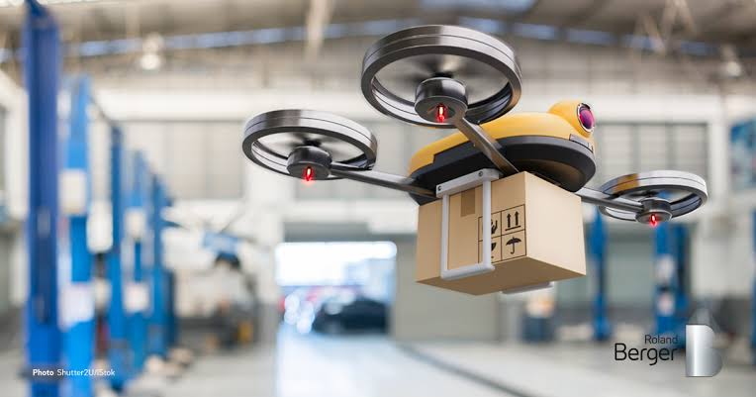

**Fig 2.8 Delivery Drone**

Delivery drones are usually autonomous UAVs that are used to transport food, packages or goods to your front doorstep. These flying vehicles are known as “last mile” delivery drones because they are used to make deliveries from stores or warehouses close by. Retailers and grocery chains all over the country are turning to drones as more efficient delivery alternative, instead of relying on delivery drivers with inefficient trucks. These drones can carry an impressive 55 pounds of goods to your front door without you ever having to leave the house. Amazon, Walmart, Google, FedEx, UPS and many other big brands are all currently testing out different versions of delivery drones**.**

**EMERGENCY RESCUE DRONES:**

Sometimes it’s just not safe enough to send humans into a rescue situation due to the scope or severity of the disaster. That’s where drones come in. In the case of a capsized boat or drowning individual, officials can throw an Autonomous Underwater Vehicle (AUV) into the water to assist in the rescue. If there’s an avalanche, drones are deployed to look for those caught in the snow. Aircraft maker, Kaman, has even developed a pilotless helicopter, called the K-MAX, designed to carry more than 6,000 pounds of cargo. The K-MAX has already been used in China and Australia to assist in fighting fires.

**WILDLIFE AND HISTORICAL CONSERVATION**:

Drones are a cheaper and more efficient alternative to wildlife conservation. Tracking wildlife populations is nearly impossible with humans on the ground. Having an eye-in-the-sky allows wildlife conservationists to track roaming groups of animals, ranging from Orangutans in Borneo to Bison on the Great Plains, to get a better idea of the health of their species and ecosystems. Conservation drones also make perfect tools in the fight against poaching efforts in Asia and Africa.

Drones are also being used for reforestation efforts all over the world. These drones scour the forest floors of forests decimated by fires and drop seed vessels filled with seeds, fertilizers and nutrients that will help a tree rise from the ashes. There have been around 300 million acres of deforested land since the early 1990’s. What would take humans around 300 years to reforest can be more efficiently completed via seed-planting drone technology.

Finally, UAVs are becoming instrumental in historical conservation efforts. Drones are being used to map out 3D renderings of historical sites like Chernobyl, the ancient Greek sites of Ephesus, Turkey and Jewish cemeteries all over Europe. The vantage point gives historical preservationists the ability to find clues about culture and architecture.

**OUTER SPACE:**

NASA and the U.S. Air Force have been secretly testing out unmanned aircraft geared towards space travel. The X-37B UAV is the Air Force’s ultra-secretive drone that looks like a miniature space shuttle. It has been quietly circling the Earth for the last two years, setting a record for longest flight from an unmanned aircraft (more than 719 days). Although vague, the Air Force has said “the primary objectives to the X-37B are twofold: reusable spacecraft technologies for America’s future in space and operating experiments which can be returned to, and examined, on Earth.” It seems that drones have been made a priority when it comes to the future of space exploration and innovation.

**CHAPTER 3**

**QUADCOPTER DRONE**

**3.1 INTRODUCTION:**

A quadcopter an aerial vehicle that uses four rotors for lift, steering, and stabilization unlike other aerial vehicle the quadcopter can achieve vertical flight in a more stable condition .Furthermore, due to the qualcopter's cycle design, it is easier to contract and maintain. As the technology becomes more advanced and accessible to the public. Many engineers and researchers have started designing and implementing quadcopter for different uses. One of the main use is surveillance is a critical for security operations. In the past helicopters were used for these types of missions Recently. Unmanned Aerial Vehicle (UAV) are (have gown n popularity and are an excellent).

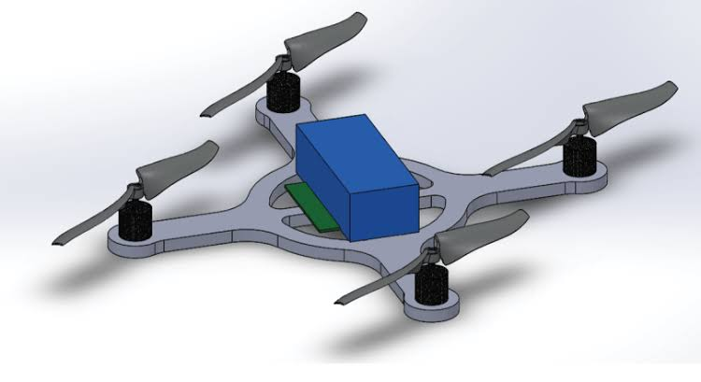

**Fig 3.1 QUADCOPTER DRONE**

Multi-rotor drones can be further classified based on the number of rotors on the platform. They are Tricopter (3 rotors), Quadcopter (4 rotors), Hexacopter (6 rotors) and Octocopter (8 rotors). Out of these, Quadcopters are the most popular and widely used variant. On the other side, multi-rotor drones are cheap – anyone with a few hundred dollars to spare can buy a decent quadcopter. Flying a quadcopter doesn’t require special training. You just take them to an open area and fly it. Guiding and controlling a quadcopter can be learned on the go. In aerodynamics, the lower the count of rotors the lesser will be the spin of the object. And that’s the big reason why quadcopters aremore stable thanoctocopters. In that sense, single rotor drones are much efficient than multi-rotor drones.

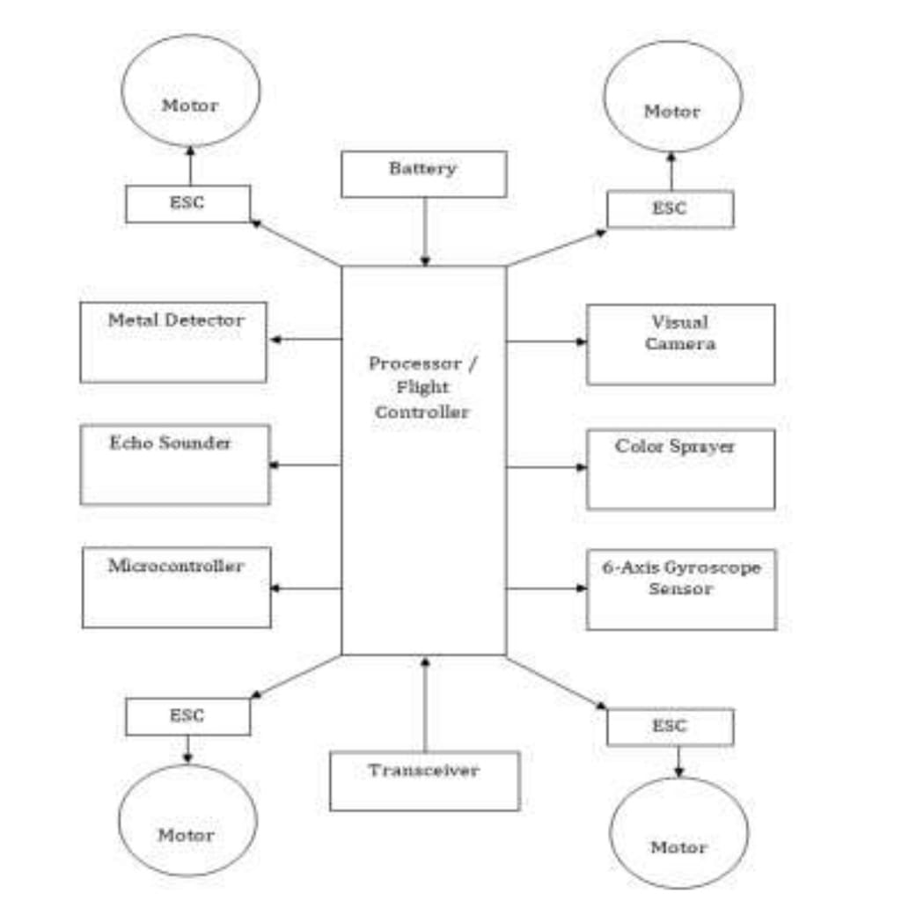

**Fig3.2 Block Diagram of UAV**

The quadcopter drones utilized for surveillance missions. The unmanned aerial vehicles are helpful to observe and analyze and get information and transfer it to base station UAVs are able to perform missions with high level of complexity and at the same time. they require less human operator involvement

The additional advantage is. they are agile in mature and can have degree of freedom up to 10. The goal of this projects to build an UAV in the structure of x shaped quad rotor that houses a camera with a wireless transmission system This unmanned aerial vehicle will be used for campus surveillance Aerial surveillance will be done by monitoring the real time environment with help of UAV Surveillance of barks, highly crowded areas, aerial traffic and security watch can be easily done with the help of this UAV.

**3.2 Background:**

Quadcopter, also known as quadrotor, is a helicopter with our rotor. The rotors are directed upwards and they are placed in a squire formation with equal distance from the center of mass of the quadcopter. The quadcopter is controlled by adjusting the angular velocities of the rotors which are spin by electric motors Quadcopter is a typical design for small UAV because of the simple structure Quadcopter are used in surveillance search and rescue. construction inspections and several other applications.

Quadcopter has received considerable attention from researhers, as the complex phenomena of the quadcopter have generated several areas of interest. The basic dynamical model of the quadcopter as the starting point for all of the studies but more complex aerodynamic properties has been introduced as well Different control methods has been researched including PID controllers, back stepping control non-linear Hi control LQR controllers, and nonlinear controller with nested Control methods require accurate information from the position and altitude measurements performed with a gyroscope, an accelerometer, and other measuring devices such as GPS, and sonar and laser sensors. PID controllers have been chosen for this project.

**3.3 Quadcopter Dynamics**:

Each rotor produces both a thrust and torque about its centre of rotation as well as a drag for opposite to the vehicle's direction of fight Quad-copter achieves it. yaw, roll and pitch simply via a manipulation of the thrusts of four motors relative to each other . This way, fixed rotor blades can be made to manoeuvre the quad rotor vehicle in all dimensions Similar to other flying objects, a quadrotor has a group of forces and torques acting on it while it flies There are four main forces acting on the drone: drag lift, weight, and thrust. In order for the drone to fly, these different forces need to be balanced. This can be seen by utilizing Newton’s second law.

Applying Newton’s Second Law

F=ma

For constant velocity acceleration is zero (a=0).Thus the sum of the forces is equal to zero. So far steady.constant velocity flight, completing a force balance in the horizontal direction on the diagram obtains:

*Ftrust-Fdrag=0*

*Ftrust=Fdrag*

Since this is for a constant velocity.the aircraft is either moving or at rest.An analysis in the vertical direction will produce similar results

*Flift-Fweight=0*

*Flift=Fweigt*

**3.4 Advantages of Quadcopter:**

1. A Drone is mostly used for surveillance by the police and military.
2. This Drone is also used for watching the streets of the city.
3. Drone is used for medical helps on the spot area of the road accidents.
4. It is also used for lifting a weight approx 400 grams etc.

**3.5 Specifications and Goals:**

The goal of our project is to design, and implement, and test a stable flying UAV quadcopter that can be used to collect the data from the ground and save the Global Positioning System (GPS) data Our plan was to choose an existing quadcopter kit and add the required components to give the quadcopter the capabilities to detect the landmines in the ground which are buried or partially buried in the ground and log data autonomously. A GPS module will be used to determine the current position and an SD card will be used to store the information needed. If this goal is accomplished, our team would also like to design and implement some autonomous commands that may help aid a user in collecting the data These commands include the auto landing command auto-move command Auto-homing command and hold position command

**The final quadcopter design had to meet the following specifications**:

1. The quadcopter must be capable of flying and landing in stable manner.
2. The quadcopter must be capable of determining its current location using GPS Data.
3. The quadcopter must be capable to storing and logging data.
4. The quadcopter must be capable of detect the landmines with an accuracy.

**CHAPTER – 4**

**Quadcopter Materials**

* **Frame**
* **DC brushless motor**
* **Electronic speed control (ESC)**
* **Propeller**
* **LI-PO battery,11V**
* **Remote control**
* **Power distribution board**
* **Camera**
* **Connectors**

**4.1 Frame:**

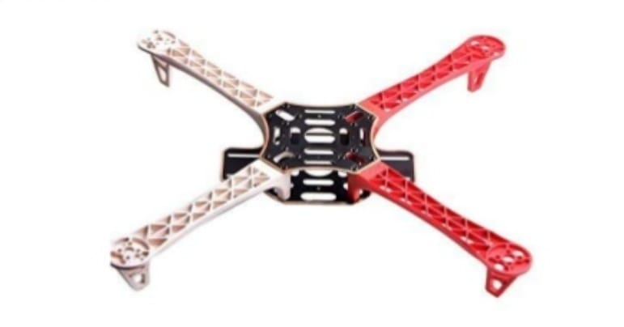

**Fig 4.1 Frame**

This is the most important basic part of a Quadcopter As the name indicates the copter has 4 arms The frame should be light as well as rigid to host a LIPO battery 4 BLDC motors,4ESC & controller.

You can build your own frame using Aluminium or wood channel But I suggest you to go for a readymade one like F450 FRAME which is easy to assemble. The frame arms are made of ultra strength material to survive any crash The frame boards are high strength compound PCB frames, which makes wring of ESCs and battery safer and easier. To make your flight colourful the frame arms come with different colours .The first thing is that choosing the best frame for quadcopter when you building a quadcopter in order to easily find the right frame for your quadcopters.I Will be listing all quadcopter frame types for you to reference.

As we know ,there are a few different types of drone:Tricopter, Quadcopter, Hexacopter, Octocopter, Y6, X8 ,But today we only are talking frame for quadcopter, so it become more easier than considering all types of drone.

**4.1.1 Considering the purpose when choosing quadcopter frame**:

One should be clear that what’s the purpose of building a quadcopter before you purchase a frame.Different choosing result in different purpose of your drone.

In general,there are 5 purposes as below of using a quadcopter.

**1. Sports FPV:**

FPV is one of the quadcopter,Which is more and more popular,Now,FPV is not only for fun but also is a racing competition sports FPV have lots of mounting surfaces? For extra electronics and action cameras.

**2. Mini FPV:**

Mini FPV is very cheap and small which is easiest to fly and is suited for the beginners.Mini FPV virtually indestructible with space to mount electronics and sometimes an action camera.

**3. Mini Quadcopter:**

Mini quadcopter is very small and indestructible. it’s very flexible that you can fly it both indoors and out doors .it’s also very light.so you can not fly in the wind

**4. sports:**

Super light-weight and extremely stiff for crisp and responsive control.All you need here is stability and good responsive control.

**5. Aerial Photography**:

Big enough to lift a specific camera with tall landing gear.Aerial photos always seem to be breathtaking and different. As they show all the objects on earth from a new perspective.

There are some tips for choosing quadcopter frame and more information about how to choose the best frame for quadcopter . Here

**4.1.2 Quadcopter frame types for different requirements**:

Its different requirements for different quadcopter types:

1. **Sports FPV Frame requirement:**

This is a combination of sports frame and camera frame. which are required to be extremely solid. This is because it will have to lift itself up with a lot of extra electronic devices and an action camera for the best results. So there should be a lot of mounting space which can hold in the components. Also it should be strong enough to take off with all that extra weight and have a stable flight which is the most important aspect here. Having a camera on board.

**2. Mini FPV Frame requirement:**

While a mini quadcopter might be one of the easiest to fly, the mini FPV can turn out to be one of the most difficult devices to build. This is because this is a small quadcopter frame in which you will have to incorporate a number of devices electronics, and sometimes even an action camera.

So, there should be a lot of space on the frame in order to mount all those electronics Also, the frame will be light, owing to its size. But it should be solid enough to carry all of that weight on its small structure. That is essential for a good fight experience.

**3. Mini Quadcopter Frame requirement**:

Mini quadcopter form the best option if you want to fly your device both indoors and outdoors. These are the easiest to fly because of their low weight and they are virtually indestructible. They can be made to fly around obstacles and have an unperturbed flight because of their small structure.

However, their range might be limited and you will always have to be careful to keep them within your line of sight. These frames are light by virtue of their size and there is not much that is on board that leads to a stable fight. With misinaltic requirements, these frames are the easiest to work with.

**4. Sports Frame requirement**:

If the idea behind purchasing the next quadcopter frame is sports, then one need the lightest mode available in the market. You do not need to attach a camera or any heavy device here.

All you need here is stability and good responsive control So the frame here should be light and crisp that will go unperturbed in the air, while coordinating with the user from the base level. Carbon fiber or light materials will work perfectly in these situations.

**5. Aerial Photography Frame requirement:**

If the aim here is to get a few aerial shots from mid-air, then one have to get a frame that is stable and has a smooth fight. This will hold the camera stand in is position Aka, the frame should be sold and big enough to it the heavy camera without losing is agility.

Also, another important aspect for this purpose is the tall landing gear which is required to keep the camera safe during is take off and landings. But most importantly, the frame should be lightweight in structure since with the camera on the system will become quite bulky.

**4.2 DC Brushless motor:**

A Brushless DC motor is an internally commutated electric motor designed to be run from a direct current power source. Brushed motors were the first commercially.

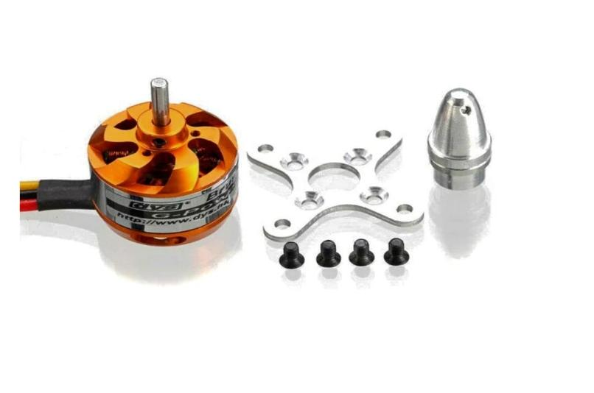

**Fig 4.2 Brushless motor**

This important application of electric power to driving mechanical energy, and DC distribution systems were used for more than 100 years to operate motors in commercial and industrial buildings. Brushed DC motors can be varied in speed by changing the operating voltage or the strength of the magnetic field. Depending on the connections of the field to the power supply, the speed and torque characteristics of a brushed motor can be altered to provide steady speed or speed inversely proportional to the mechanical load. Brushed motors continue to be used for electrical propulsion cranes, paper machines and steel rolling mills. Since the brushes wear down and require replacement,brush less DC motors using power electronic devices have displaced brushed motors from many applications.

When a current passes through the coil wound around a soft iron core, the side of the positive pole is acted upon by an upwards force, while the other side is acted upon by a downward force. According to Fleming's left hand rule, the forces cause a tuning effect on the coil making it rotate. To make the motor rotate in a constant direction "direct current commutator make the current reverse in direction every half a cycle (in a two-pole motor) thus causing the motor to continue to rotate in the same direction.”

A problem with the motor shown above is that when the plane of the coil is parallel to the magnetic field- I.e when the rotor poles are 90 degrees from the stator poles the torque is zero. This occurs when the core of the coil is horizontal the position is just about to reach in the last picture on the right. The motor would not be able to start in this position. However, once it was started, it would continue to rotate through this position by momentum.

There is a second problem with this simple pole design At the zero-torque position both commutator brushes are touching (bridging) both commutator plates, resulting in a short-circuit. The power leads are shorted together through the commutator plates, and the coil is also short-circuited through both brushes (the coil is shorted twice. once through each brush independently) Note that this problem is independent of the non-starting problem above: even if there were a high current in the coil at this position, there would still be zero torque. The problem here is that this short uselessly consumes power without producing any motion (nor even any coil current) In a low current battery-powered demonstration this short-circuiting is generally not considered harmful. However, if a two-pole motor were designed to do actual work with several hundred watts of power output, this shorting could rest in severe commutator overheating brush damage, and potential welding of the brushes.if they were metallic to the commutator, Carbon brushes, which are often used, would not weld. In any case, a short like this is very wasteful, drains batteries rapidly and, at a minimum requires power supply components to be designed to much higher standards than would be needed just to run the motor without the shorting.

**4.2.1 BLDC Motor Advantages:**

Here is a basic breakdown of some of the primary advantages of the BLDC motor.

* **High Speed Operation** :A BLDC motor can operate at speeds above 10. 000 rpm under loaded and unloaded conditions.
* **Responsiveness & Quick Acceleration**: Inner rotor Brushless DC motors have low rotor inertia, allowing them to accelerate, decelerate, and reverse direction quickly.
* High Power Density BLDC motors have the highest running torque per cubic inch of any DC motor.
* **High Reliability** :BLDC motors do not have brushes, meaning they are more reliable and have life expectancies of over 10,000 hours. This results in fewer instances of replacement or repair and less overall down time for your project.

**4.2.2 Brushless vs brushed motors**:

Brushed DC motors have been around since the mid-19th century, but brushless motors are a fairly recent arrival a first step in the 1960s thanks to advances in solid state technology, with further improvements in the 1980s thanks to better permanent magnet material.

Brushed DC motors develop a maximum torque when stationary, Iinearly decreasing as velocity increases. Some Imitations of brushed motors can be overcome by brushless motors they include higher efficiency and a lower susceptibility to mechanical wear. These benefits come at the cost of potentially less rugged, more complex, and more expensive control electronics.

A typical brushless motor has permanent magnets which rotate around a fixed armature, eliminating problems associated with connecting current to the moving armature. An electronic controller replaces the brush/commutator assembly of the brushed DC motor, which continually switches the phase to the windings to keep the motor turning.The controller performs similar timed power distribution by using a soild-state circuit rather than the brush/commuator system.

Brushless motors offer several advantages over brushed DC motors, including high torque to weight ratio, more torque per watt (increased efficiency) increased reliability ,reduced noise, longer lifetime (no brush and commutator erosion),of electromagnetic interference. With no windings on the rotor, they are not subjected to centrifugal forces, and because the windings are supported by the housing, they can be cooled by conduction requiring no airflow inside the motor for cooling. This in turn means that the motor's internals can be entirely enclosed and protected from dirt or other foreign matter, Brushless motor commutation can be implemented in software using a microcontroller or microprocessor computer, or may alternatively be implemented in analogue hardware, or in digital firmware an FPGA Commutation with electronics instead of brushes allows for greater flexibility and capabilities not available with brushed DC motors, including speed limiting micro stepped operation for slow and/or fine motion control, and a holding toque when stationary Controller software can be customized to the specific motor being used in the application resulting in greater commutation efficiency.

The maximum power that can be applied to a brushless motor is limited almost exclusively by heat: too much heat weakens the magnets and may damage the winding's insulation.

When converting electricity into mechanical power, brushless motors are more efficient than brushed motors. This improvement is largely due to the frequency at which the electricity is switched determined by the position sensor feedback. Additional gains are due to the absence brushes, which reduces mechanical energy loss is due to friction. The enhanced efficiency is greatest in the no-bad and low-load region of the motor's performance curve. Under high mechanical loads, brushless motors and high-quality brushed motors are comparable in efficiency.

Environments and requirements in which manufacturers use brushless type DC motors include maintenance-free operation, high speeds, and operation where sparking is hazardous or could affect electronically sensitive equipment.

**4.2.3 Applications of BLDC motors:**

The four poles on the stator of a two phase brushless motor. This is a part of a computer cooling fan, the rotor has been removed, Brushless motors fulfill many functions. originally performed by brushed DC motors, but cost and control complexity prevents brushless motors.

from replacing brushed motors completely in the lowest-cost areas Nevertheless, brushless motors have come to dominate many applications, particularly devices such as computer hard drives and CD/DVD players. Small cooling fans in electronic equipment are powered exclusively by brushless motors. They can be found in cordless power took where the increased efficiency of the motor leads to longer periods of use before the battery needs to be charged. Low speed, low power brushless motors are used in direct-drive turntables for gramophone records.

**Motion control systems:**

Brushless motors are commonly used as pump, tan and spindle drives in adjustable or variable speed applications. They can develop high torque with good speed response In addition, they can be easily automated for remote control. Due to their construction they have good thermal characteristics and high energy efficiency. To obtain a variable speed response, brushless motors operate in an electro-mechanical system that includes an electronic motor controller and a rotor position feedback sensor.

Brushless DC motors are widely used as servomotors for machine tool servo drives Servomotors are used for mechanical displacement, positioning or precision motion control in the past DC stepper motors were used as servomotors; however, since they are operated with open loop control, they typically exhibit torque pulsations, Brushless dc motors are more stable as servomotors since their precise motion is based upon a closed loop control system that provides tightly controlled and stable operation.

**Positioning and actuation systems**:

Brushless motors are used in industrial positioning and actuation applications. For assembly robots, brushless stepper or servo motors are used to position a part for assembly or a tool for a manufacturing process, such as welding or painting Brushless motors can also be used to drive linear actuators.

Motors that directly produce linear motion are called linear motors. The advantage of linear motors is that they can produce linear motion without the need of a transmission system, such as a ball-and-lead screw, rack-and-pinion, cam, gears or bells that would be necessary for rotary motors. Transmission systems are known to introduce less responsiveness and reduced accuracy. Direct drive, brushless DC Iinear motors consist of a slotted stator with magnetic teeth and a moving actuator, which has permanent magnets and coil windings. To obtain Iinear motion, a motor controller excites the coil windings in the actuator causing an interaction of the magnetic fields resulting in linear motion. Tubular linear motors are another form of linear motor design operated in a similar way,

**Aero modeling**:

A microprocessor controlled BLDC motor powering a micro radio controlled airplane .This external rotor motor weights 5g and consumes approximately 11w.

Brushless motors are a popular motor choice for model aircraft including helicopters and drones. Their favorable power-to-weight ratios and large range of available sizes from under 5 gram to large motors rated as well as into the kilowatt output range, have revolutionized the market for electric-powered model flight, displacing virtually all brushed electric motors. They have also encouraged a growth of simple, lightweight electric model aircraft, rather than the previous internal combustion engines powering larger and heavier models. The large power-to-weight ratio of modern batteries and brushless motors allows models to ascend vertically, rather than climb gradually. The low noise and lack of mass compared to small glow fuel internal combustion engines is another reason for their popularity.

Legal restrictions for the use of combustion engine driven model aircraft in some countries, most often due to potential for noise pollution even with purpose-designed mufflers for almost all model engines being available over the most recent decades - have also supported the shit to high-power electric systems.

**4.3 Electronic speed control**

An electronic speed control or ESC is an electronic circuit with the purpose to vary an electric motor's speed, its direction and possibly also to act as a dynamic brake ESCs are often used electrically powered radio controlled model, with the variety most often used for brushless motors essentially providing an electronically generated three-phase electric power low voltage source of energy for the motor.

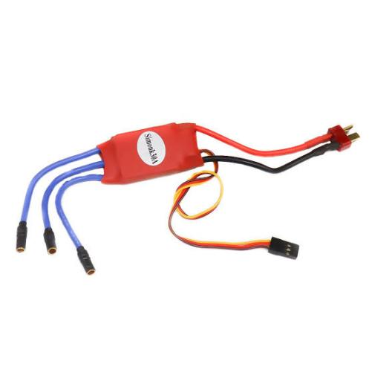

**Fig4.3 Electronic speed control (ESC)**

ESC supplies power from battery but not constant, it varies according to input signal ESC also has BEC (Battery Eliminated Circuit). BEC is nothing but 5V output from ESC that can power up receiver, servo motor and FC. One only need to keep in mind that Ampere rating of ESC should be higher than max amp rating of motor. For example the motor we selected draws maximum 15Amp so your ESC rating should be higher than 15amp. Say 18-20Amp. One can select ESC between ranges of 18A to 22A. 20 Amps was selected as our designed requirement.

An ESC can be a stand-alone unit which plugs into the receiver's throttle control channel or incorporated into the receiver itself, as is the case in most toy-grade R/C vehicles. Some R/C manufacturers that install proprietary hobby-grade electronics in their entry-level vehicles, vessel or aircraft use on board electronic that combine the two on a single circuit board.

A generic ESC module rated at 35 amperes with an integrated BEC. ESC system for brushed motors are very different by design as a result brushed ESC's are not compatible with brushless motors. Brushless ESC system basically create a tri-phase AC power output of limited voltage from an on-board DC power input, to run brushless motors by sending a sequence of AC signal generated from the ESC's circuitry, employing a very low impedance for rotation. Brushless motors, otherwise called out runners or in runners depending on their physical configuration have become very popular with electro flight radio-control aero modeling hobbyists because of their efficiency. power, longevity and light weight in comparison to traditional brushed motors However, brushless AC motor controllers are much more complicated than brushed motor controllers.

The correct phase varies with the motor rotation, which is to be taken into account by the ESC: Usually, back EMF from the motor is used to detect this rotation, but variations exist that use magnetic (Hall Effect) or optical detectors. Computer programmable speed controls generally have user-specified options which allow setting low voltage cut-off limits, timing acceleration, braking and direction of rotation. Reversing the motor's direction may also be accomplished by switching any two of the three leads from the ESC to the motor.

ESC s are normally rated according to maximum current for example 25 amperes or 25 A. Generally the higher the rating the larger and heavier the ESC tends to be which a factor when calculating mass is and balance in airplanes. Many modern ESCs support nickel metal hydride, lithium ion polymer and lithium iron phosphate batteries with a range of input and cut-off voltages. The type of battery and number of cells connected is an important consideration when choosing a Battery eliminator circuit (BEC), whether built into the controller or as a stand-alone unit. A higher number of cells connected will result in a reduced power rating and therefore a lower number of servos supported by an integrated BEC, if it uses a linear voltage regulator. A well designed BBC using a switching regulator should not have a similar limitation.

**ESC for Quadcopter :**

Electronic Speed Controllers (ESC) are an essential component of modern quadcopter (and all multirotor) that offer high power, High frequency, high resolution 3-phase AC power to the motors in an extremely compact miniature package. These craft depend entirely on the variable speed of the motors driving the propellers. This wide variation and the fine RPM control in motor/prop speed gives all of the control necessary for quadcopter (and all multi rotor) to fly.

Height is determined by the amount of power to all four motors Forward motion is achieved by driving the aft (back) props faster than the forward props. Sideways motion is achieved by running the left or right props faster. Rudder movements (yaw), (turning left or right) are again achieved by slowing or speeding individual motors and this control is reliant on the fact that two of the rotors rotate clockwise while the other two rotate counterclockwise so that, again, showing or speeding individual motors (and props) will produce a change in attitude in the craft.

Quadcopters are a rapidly growing hobby subject but also provide aerial mounts for video cameras for sports coverage, agricultural research inspection of electrical pylons and historic exploration.

Quadcopter ESCs usually can use a faster update rate compared to the standard 50 Hz signal used in most other RC applications. PWM signals up to 400 Hz can be used in some cases, and other control options can increase this rate even higher. Also some software delays, such as low-pass filters, are removed in order to improve control latency.

**4.4 Propeller:**

A Propeller is a type of fan that converts rotational motion into thrust and transmit the generated power. There are three simple measurements to keep in mind .The first is length.

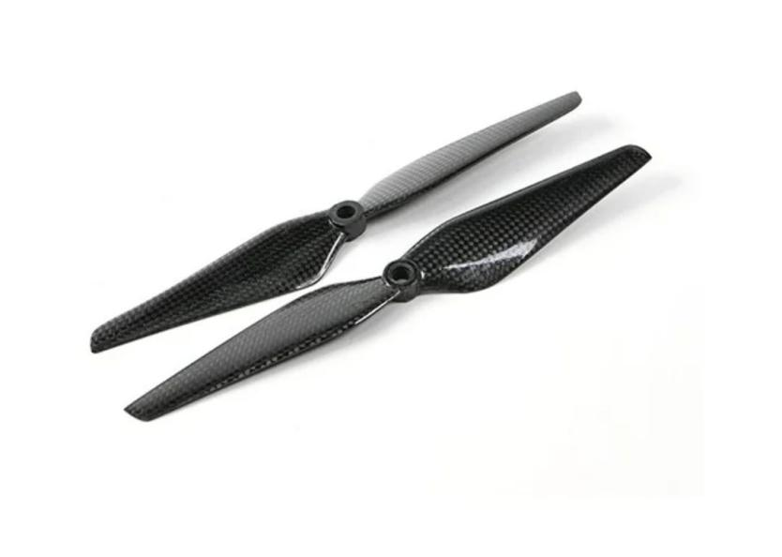

**Fig 4.4 Propellers**

Usually given in inches. The higher the Kv of your motors, the smaller your props need to be. Smaller props allow for greater speeds, but reduced efficiency. A larger prop setup (with correspondingly-low Kv motors) is easier to fly steadily, uses less current, and lifts more weight.

The second measurement, prop pitch, is less important, but of interest to more vigorous hobbyists. Prop dimensions are quoted in the form 9 x 4.7", as a numerical example. The first number refers to the already-discussed length. The second is pitch, defined as the distance a prop would be pulled forward through a sold in a single full revolution, as if a screw through wood. The greater the pitch the higher the thrust and necessary motor output. Typically, multi-rotors use props with pitches in the range of 3 to 5 inch. Lower pitches are more efficient, but lend a more sedate flying style.

Finally, we have bore measurement, which is simply the size of the hole in the center of the prop. This must be matched to the shaft of your chosen motors. Adapters are available to downsize a prop's bore Alternatively, some props, such as those produced by T-Motor, use a direct mounting system whereby screws secure the props directly to the motor head.

**4.4.1 Requirements :**

The propellers shall be large enough to provide adequate it for the quadcopter, but small enough to fit on the chosen frame. Propellers are also specific to the direction of rotation, making it necessary to match propellers with motors.

**4.4.2 Alternatives:**

Carbon fiber or plastic propellers both fit project needs. There are propellers that range in length from 4 to 22 inches and with pitches ranging from 2 to 12 degrees.

**4.4.3 Decision Criteria:**

The choice between plastic or carbon fiber propellers depended on multiple factors. The blades needed to be robust enough to handle moderate collisions, balanced enough to limit vibrations, and have appropriate length and pitch vales Motors driving the propellers are rated for specific propeller sizes, so this was taken into effect as well. Larger propellers (and those with a higher pitch) can provide more lift because they move more air, but they also require more power. Cost was another factor, as multiple crashes were anticipated with a new quad copter design.

**4.4.4 Decision:**

The team chooses to continue using plastic propellers. Carbon fiber propellers are more expensive and much stronger, making them even more dangerous if they were to contact an object or a person. Due to the nature of the project with many new components of hardware and software coming together, the team anticipated multiple crashes. Keeping this in mind, the team chose plastic propellers to help stay under budget while providing a safer product for the user. The team specifically selected APC propellers for their build quality. The length chosen 8 inch with a pitch of 45 degrees as this provided the best balance of it without sacrificing stability.

Propellers were not tested in a specific way other than during test flights of the quadcopter. The team observed that propellers of 10 inch and with a pitch equal to 4.5 degrees made the quadcopter too sensitive to user input. However, the larger the propeller, the more lift the quadcopter experienced. As such, the team settled on 8 inch, 45 degree propellers because they have good it while leaving the quadcopter stable.

**4.5 Li-Po Battery**

A lithium polymer battery, or more correctly lithium-ion polymer battery (abbreviated variously as Li-Po, LIP, Li-poly and others), is a rechargeable battery of lithium-ion technology using a polymer electrolyte instead of the more common quid electrolyte. High conductivity semisolid (gel) polymers form the electrolyte for LI-Po cells that are being used in tablet computers and many cellular telephone handsets.

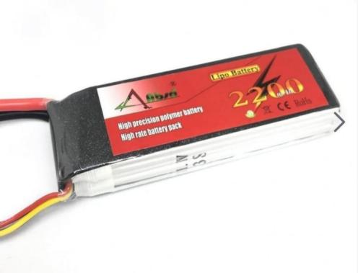

**Fig 4.5 Li-Po Battery**

The battery powering the quadcopter shall provide power for all on –board sensors and computers as well as the ESCs and motors.The battery shall provide power for the equipment for a minimum of approximate six minutes without overheating. The battery shall also have protective circuitry to prevent overcharging and over discharging which can cause batteries to catch fire and explode.

Lithium Polymer LI-PO are a type of rechargeable battery that has taken the electric RC world by storm especially for Quadcopter. They are the main reason electric fight now a very visible option over fuel powered models Li-Po batteries are light in weight & hold huge power in a small package. They have high discharge rates to meet the need of powering quadcopter, remember Li-Po batteries are much expensive& have life time of only 300 in 400 charge cycles Special care to be taken to Charge discharge or store the Li-Po. Because of the volatile electrolyte used in Li-Po they can burst or catch fire easily when mishandled.

Unlike conventional Ni-Cad battery cells that have a voltage of 1.2 volts per cell Li-Po battery cell are rated at 3.7 volts per cell So you get in multiples of 3.7v like 74 & 11.1 v batteries.

RC Li-Po battery packs will have at least two or more cells hooked up in series to provide higher voltages. So a 11.1 v battery, which is widely used, has 3 cells x 37 volts (35) Capacity indicates how much power the battery pack can hold and is indicated in milli amp hours (mAh). A 3200 mAh would be completely discharged in one hour with a 3200 milli-amp load placed on it. If the same battery had an 1100 milli amp load placed on it, it would take 2 hours to drain down. If you want to increase your fight time use more capacity battery l.e 3000maH.

Li-Po batteries can be found in packs of everything from a single cell (3.7V) to over 10 cells (37V). The cells are usually connected in series, making the voltage higher but giving the same amount of amp-hours.

Another thing to be aware of when selecting the right battery is the discharge rate, formerly known as the C-vale. The C-vale together with the battery capacity indicates how much current you are able to source from the battery.The calculations follow this simple rule:

Max Source=Discharge Rate * Capacity

For e.g. take a battery of capacity 4000maH, with a discharge rate of 20C mentioned. With this battery you will be able to source a maximum of 20Cx4000mAh = 80A. So in this case you should make sure that the total amount of current drawn by your motors (ESCs) won't exceed 80A.

Discharge rate is simply how fast a battery can be discharged safely. In the RC Li-Po battery world it is called the "C" rating. Remember you should never discharge a Li-po battery below 80% of its capacity.

**4.6 Remote controls:**

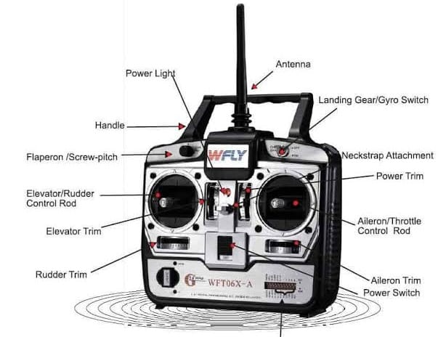

**Fig 4.6 Remote Controller**

We need a RC Transmitter(2.4GHz RC radio transmitter) to direct the quadcopter direction and position.

A 2.4GHz RC radio on the Quadcopter receives commands from the RC transmitter on the ground..One get a Receiver along with the corresponding Transmitter.

The transmitter is the hand-held controller you use to remotely control your craft.The transmitter have two sticks, two trim buttons or a slider per stick a number of switches, a display and a power button.

Transmitter and receivers need a frequency range to operate and the new frequency range is 2.4GHz with digital spectrum modulation 2.4GHz is the ISM(Industrial, scientific & medical) Radio band which needs to license to operate.

**CHAPTER 5**

**MECHANICS OF DRONE**

**5.1 Material composition**

A typical unmanned aircraft is made of light composite materials to reduce weight and increase maneuverability. This composite material strength allows military drones to cruise at extremely high altitudes.UAV drones are equipped with different state of the art technology such as infrared cameras, GPS and laser (consumer, commercial and military UAV). Drones are controlled by remote ground control systems (GSC) and also referred to as a ground cockpit.An unmanned aerial vehicle system has two parts, the drone itself and the control system.The nose of the unmanned aerial vehicle is where all the sensors and navigational systems are present. The rest of the body is full of drone technology systems since there is no space required to accommodate humans.The engineering materials used to build the drone are highly complex composites designed to absorb vibration, which decrease the sound produced. These materials are very light weight.

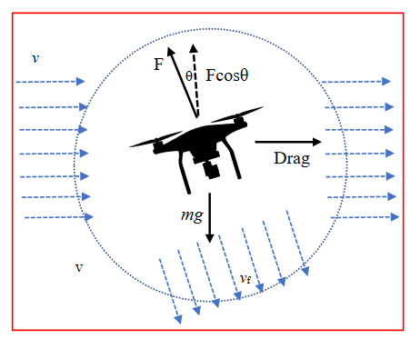

**Fig 5.1 Angle of Drone**

**5.2 Motion**:

Drones use rotors for propulsion and control. A rotor is generally a fan as they work pretty much the same. Spinning blades push air down. Of course, all forces come in pairs, which means that as the rotor pushes down on the air, the air pushes up on the rotor. This is the basic idea behind lift, which comes down to controlling the upward and downward force. The faster the rotors spin, the greater the lift, and vice-versa.a drone can do three things in the vertical plane: hover, climb, or descend.

**Hover:**

To hover, the net thrust of the four rotors pushing the drone up must be equal to the gravitational force pulling it down.

**Descend:**

To descend, the net thrust of the four rotors pushing the drone up must be less than that of the gravitational force pulling it down.

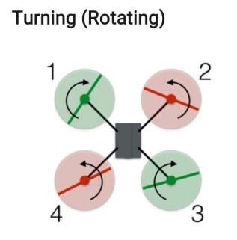

**Fig 5.2 Turning**

In this configuration, the red rotors are rotating counterclockwise and the green ones are rotating clockwise. With the two sets of rotors rotating in opposite directions, the total angular momentum is zero. Angular momentum is a lot like linear momentum, and you calculate it by multiplying the angular velocity by the moment of inertia.If there is no torque on the system, then the total angular momentum must remain constant (zero in this case).

**Forwards and Sideways:**

In order to fly forward, There is a need of forward component of thrust from the rotors. Here is a side view (with forces) of a drone moving at a constant speed

.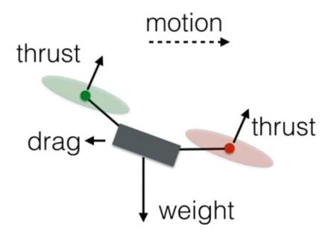

**Fig 5.3 Forwards and Sideways**

The total thrust force will remain equal to the weight, so the drone will stay at the same vertical level. Also, since one of the rear rotors is spinning counterclockwise and the other clockwise, the increased rotation of those rotors will still produce zero angular momentum. The same holds true for the front rotors, and so the drone does not rotate. However, the greater force in the back of the drone means it will tilt forward. Now a slight increase in thrust for all rotors will produce a net thrust force that has a component to balance the weight along with a forward motion component.

**Using a computer:**

Every movement is accomplished by changing the spin rate of one or more rotors. Doing that simply requires a controller that can increase or decrease the voltage to each motor. But just imagine this---you have a drone with 4 controllers. We will need one controller for each motor power level. It would be difficult to manually adjust each motor power to achieve the desired motion.

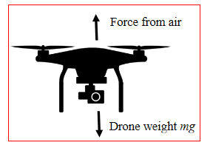 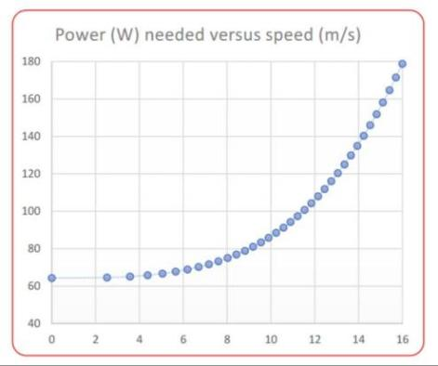

**Fig 5.4 Drone Fig 5.4 (a) power(W) vs (m/s)[Reference quoted in Paper(1)]**

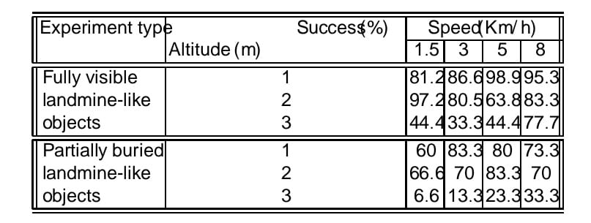

**Table 5.1(a) Numerical Values Of The Experiment**

However, if we have some type of computer control system, we can simply push a joystick with your thumb and let a computer handle all of that. An accelerometer and gyroscope in the drone can further increase the ease and stability of flight by making minute adjustments in the power to each rotor. We can add a GPS system and can pretty much get rid of the human entirely.

**CHAPTER 6**

**Metal Detector**

**6.1 INTRODUCTION**

A metal detector is an instrument that detects the presence of metal nearby. Metal detectors are useful for finding metal inclusions hidden within objects, or metal objects buried under ground. If the sensor comes near a piece of metal this is indicated by a changing tone in earphones, or a needle moving on an indicator. Usually the device gives some indication of distance; the closer the metal is, the higher the tone in the earphone or the higher the needle goes.

The simplest form of a metal detector consists of an oscillator producing an alternating current that passes through a coil producing an alternating magnetic field. If a piece of electrically conductive metal is close to the coil, eddy currents will be induced (inductive sensor) in the metal, and this produces a magnetic field of its own. If another coil is used to measure the magnetic field (acting as a magnetometer), the change in the magnetic field due to the metallic object can detected .

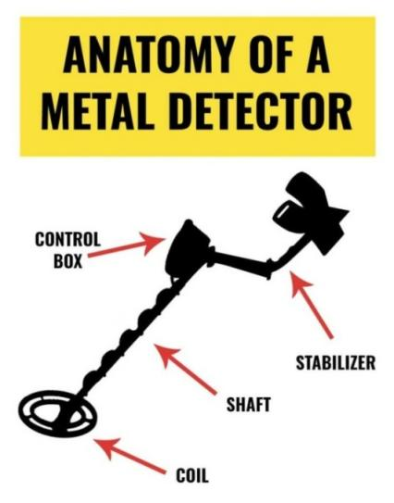 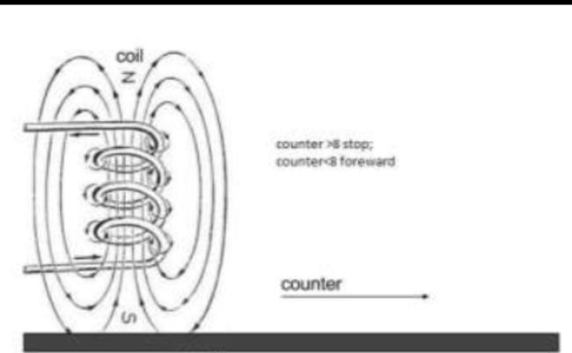 **Fig 6.1 Anatomy of metal detector**

**6.2 Brief history of Metal detectors**

Metal detectors apparently date back to the shooting of US President James A. Garfield in July 1881. One of the bullets aimed at the President lodged inside his body and couldn't be found. Telephone pioneer Alexander Graham Bell promptly cobbled together an electromagnetic metal-locating device called an induction balance, based on an earlier invention by German physicist Heinrich Wilhelm Dove. Although the bullet wasn't found and the President later died, Bell's device did work correctly, and many people credit it as the very first electromagnetic metal locator.

**6.3 Principle of a Metal detector**

A metal detector contains a coil of wire (wrapped around the circular head at the end of the handle) known as the transmitter coil. When electricity flows through the coil, a magnetic field is created all around it. As you sweep the detector over the ground, you make the magnetic field move around too. If you move the detector over a metal object, the moving magnetic field affects the atoms inside the metal. In fact, it changes the way the electrons (tiny particles "orbiting" around those atoms) move. Now if we have a changing magnetic field in the metal, we must also have an electric current moving in there too. In other words, the metal detector creates (or "induces") some electrical activity in the metal. If we have electricity moving in a piece of metal, it must create some magnetism as well. So, when you move a metal detector over a piece of metal, the magnetic field coming from the detector causes another magnetic field to appear around the metal.

It's this second magnetic field, around the metal, that the detector picks up. The metal detector has a second coil of wire in its head (known as the receiver coil) that's connected to a circuit containing a loudspeaker. As you move the detector about over the piece of metal, the magnetic field produced by the metal cuts through the coil. Now if you move a piece of metal through a magnetic field, you make electricity flow through it. So, as you move the detector over the metal, electricity flows through the receiver coil, making the loudspeaker click or beep.The closer you move the transmitter coil to the piece of metal, the stronger the magnetic field the transmitter coil creates in it, the stronger the magnetic field the metal creates in the receiver coil, the more current that flows in the loudspeaker, and the louder the noise.

**6.3.1 Circuit Diagram**

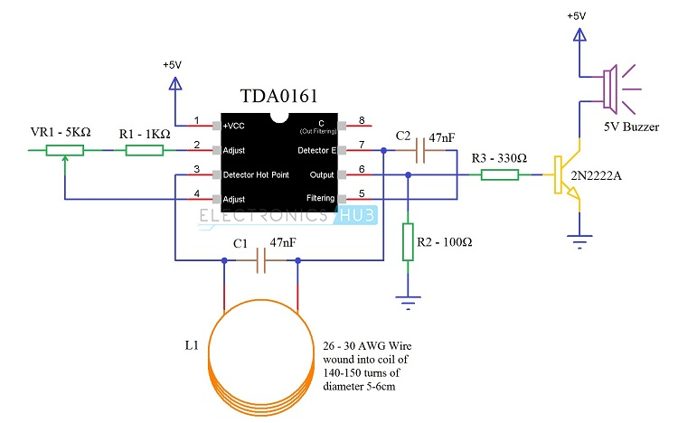

**Fig 6.2 Circuit Diagram of Metal Detector**

**Components of the Circuit:**

1. 1 x TDA0161 Proximity Detector IC
2. 2 x 47nF Capacitors (Ceramic Capacitor code 473)
3. 1 x 1 KΩ Resistor (1/4 Watt)
4. 1 x 330 Ω Resistor (1/4 Watt)
5. 1 x 100 Ω Resistor (1/4 Watt)
6. 1 x 5 KΩ Potentiometer
7. 1 x 2N2222A (NPN Transistor)
8. 1 x 5V Buzzer
9. Coil (copper wire of 26 – 30 AWG)
10. Additional Components (for LED)
11. 1 x 220 Ω Resistor (1/4 Watt)
12. LED

**6.4 Metal Detector Circuit**

* When the LC circuit that is L1 and C1 has got any resonating frequency from any metal which is near to it, electric field will be created which will lead to induces current in the coil and changes in the signal flow through the coil.
* Variable resistor is used to change the proximity sensor value equal to the LC circuit, it is better to check the value when there is coil not near to the metal. When the metal is detected the LC circuit will have changed signal. The changed signal is given to the proximity detector (TDA 0161), which will detect the change in the signal and react accordingly. The output of the proximity sensor will be of 1mA when there is no metal detected and it will be around 10mA when coil is near to the metal
* When the output pin is high the resistor R3 will provide positive voltage to transistor Q1. Q1 will be turned on and led will glow and buzzer will give the buzz. Resistor r2 is used to limit the current flow.

**Block Diagram of Metal Detector**

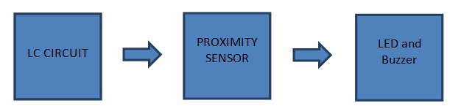

**Fig 6.3 Block Diagram of Metal Detector**

There are three main parts in the metal detector circuit: the LC Circuit, the Proximity Sensor , output LED and the Buzzer. The coil and the capacitor C1, which are connected in parallel, will form the LC circuit.

**Proximity sensor** is triggered by this LC circuit if any metal is detected. The Proximity sensor will then turn on the led and produces alarm using buzzer.

**LC Circuit:** LC circuit has inductor and capacitor connected in parallel. This circuit starts resonating when there is same frequency material near to it. The LC circuit charges capacitor and inductor alternatively. When the capacitor is charged fully ,charge is applied to inductor.

**Proximity Sensor:** The proximity sensor can detect the objects with out any physical interference. The proximity sensor will work same as infrared sensor, proximity also release a signal, it will not give output unless and until there is no change in the reflected back signal.

If there is a change in signal it will detect and give the output accordingly. There are different proximity sensors for example to detect plastic material we can use capacitive type proximity and for metals we should use inductive type.

### 6.4.1 Working of the Circuit

The LC Circuit, which consists of L1 (coil) and C1, is the main metal detector part of the circuit. With the help of this LC Circuit, which is also called as Tank Circuit or Tuned Circuit, the TDA0161 IC acts as an oscillator and oscillates at a particular frequency.

When the LC circuit detects any resonating frequency from any metal which is near to it, electric field will be created which will lead to induces current in the coil and changes in the signal flow through the coil.

Variable resistor is used to change the proximity sensor value equal to the LC circuit, it is better to check the value when the coil is not near any metal object. When the metal is detected, the LC circuit will have changed signal.

The changed signal is given to the proximity detector (TDA 0161), which will detect the change in the signal and react accordingly. The output of the proximity sensor will less than 1mA when there is no metal detected and it will be around 10mA (usually greater than 8mA) when coil is near to the metal.

When the output pin is high, the resistor R3 will provide positive voltage to transistor Q1. Q1 will be turned on and LED will glow (not shown in the circuit) and buzzer will be activated.

**Working of a metal detector**

Together with the circuit and other external hardware components, the metal detector works according to the following manner

1. A battery in the top of the metal detector activates the transmitter circuit (red) that passes electricity down through a cable in the handle to the transmitter coil (red) at the bottom.
2. When electricity flows through the transmitter coil, it creates a magnetic field all around it.
3. If you sweep the detector above a metal object (such as this old gray spanner), the magnetic field penetrates right through it.
4. The magnetic field makes an electric current flow inside the metal object.
5. This flowing electric current creates another magnetic field all around the object. The magnetic field cuts through the receiver coil (blue) moving about up above it. The magnetic field makes electricity flow around the receiver coil and up into the receiver circuit (blue) at the top, making a loudspeaker buzz and alerting you you've found something.

**Key Detecting Concepts**

**Frequency**

The frequency of a metal detector is one of the main characteristics that determines how well targets can be detected. Generally, a single frequency detector that transmits at a high frequency will be more sensitive to small targets and a single frequency detector that transmits at low frequencies will give more depth on large targets.

**Ground Balance**

Ground Balance is a variable setting that increases detection depth in mineralised ground. This ground may contain salts, such as in wet beach sand or fine iron particles, such as in red earth. These minerals respond to a detector’s transmit field in a similar way that a target does. Due to the much larger mass of the ground compared to a buried target, the effect of mineralisation can easily mask small targets. To correct this the Ground Balance setting removes the responding ground signals, so you clearly hear target signals and are not distracted by ground noise.

**Discrimination**

Discrimination is a metal detector’s ability to identify buried targets based on their conductive and/or ferrous properties. By accurately identifying a buried target you can decide to dig it up or consider it as junk and continue searching.

**Detection Depth Factors**

Detection depth depends upon detector technology and many environmental factors. The depth that a metal detector can detect a target depends on a number of factors:

|  |  |
| --- | --- |
| target size | **Target Size**  Large targets can be detected deeper than small targets. |
| Target shape | **Target Shape**  Circular shapes like coins and rings can be detected deeper than long thin shapes like nails. |
| target orientation | **Target Orientation**  A horizontal coin (e.g. lying flat) can be detected deeper than a vertical coin (e.g. on edge). |
| target material | **Target Material**  High conductive metals (e.g. silver) can be detected deeper than low conductive metals (e.g. lead or gold). |

**Fig 6.4 Detecting of Materials of Different Depths**

* The size, shape, and type of the buried metal object: bigger things are easier to locate at depth than small ones.
* The orientation of the object: objects buried flat are generally easier to find than ones buried with ends their facing downward, partly because that creates a bigger target area but also because it makes the buried object more effective at sending its signal back to the detector.
* The age of the object: things that have been buried a long time are more likely to have oxidized or corroded, making them harder to find.
* The nature of the surrounding soil or sand you're searching.
* The type of detector and the frequency (or frequencies) it's using. Generally speaking metal detector works at a maximum depth of about 20-50cm.or 8-20 inch .

**Chapter 7**

**Landmine Detection Drone**

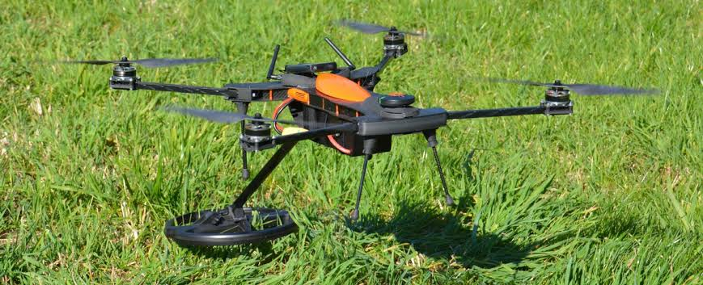

**Fig 7.1 Landmine detection drone**

Landmines are broadly classified into two types:

* Antipersonnel and
* Anti-vehicle mines.

Both have caused a great suffering in the past decades. In order to tackle one of the long standing problems causing great distress and loss to the people of several countries affected by landmines, around 150 countries have formed a treaty to decrease the number of casualties and increase in the number of mine free countries. There are approximately about 110 million landmines in 70 countries. Out of them only 40 million are destroyed so far. Mine fields which are left after the wars or planted by terrorists claim more than 80,000 deaths every year. 80% of the victims are of anti-personnel mines, in which most of them are children.

Anti-personnel landmines are usually buried 1-4 cm beneath the soil and require about 9 kg minimum pressure to detonate them. So it is very important that the robot designed for this purpose is light weight and at the same time should be able to traverse in rough and uneven terrain to fulfill the purpose. Our proposed bot is simple and light weight and can move freely in the landmine area. The anti-tank mines are usually placed under the earth and close to the surface of the earth. This robot is able to detect landmines up-to an accuracy of about 90% and it detects the landmines based upon their dimensions which helps to find the exact place of the landmine. It can detect the landmine which is at a depth of 5-9 cm depending upon the soil and the difference in the metals. It can also move easily on hilly and terrain areas which enables it to detect landmines even in rough and rough terrains.

Explosives landmines represents one of the most risky issues for people that live in conflict areas. The military has been the first to deploy machines as an attempt to overcome the risks involved when the landmine detection process is carried out by humans. Currently, there are fully autonomous systems which do not require a human operator for monitoring both detection and deactivation of explosive landmines, however these systems are highly expensive and also require qualified personnel .

In this framework, the Ursula project has been using a mobile wheeled robot to patrol and detect landmines mostly in flat fields. Nonetheless, the use of ground vehicles introduces several risky situations in cases where the system fails during the detection process. Likewise, the morphology of the robot constrains the area coverage task to uncluttered and flat ground scenarios.

To overcome these drawbacks, the use of Unmanned Aerial Vehicles (UAV) enable several capabilities that enhance both navigation and security aspects of a landmine detection mission. Firstly, an UAV is able to autonomously cover a larger area of any type of terrain in less time and without compromising the mission. Secondly, it can be also used as a remote sensing platform for collecting key information about the terrain. Terrain information can be acquired using visual methods based on target localization , tracking and image mosaicing techniques which might provide a better understanding about the area to be covered.

The UAV is remotely controlled from a base station that uses the Robot Operating System (ROS) environment for handling wireless communication, remote operation, flight control, image acquisition, filtering, pre-processing and the final landmine detection.

**CHAPTER 8**

**STAGES OF FABRICATION**

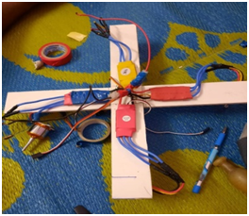**Stage 1**: In stage 1, we have taken a frame (a low cost and a light-weight frame) and fixed the Electronic speed controllers to the frame.

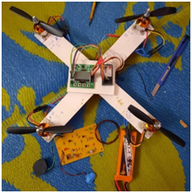**Stage 2**: In stage 2, we attached DC motors to the frame with help of screws and glue. The DC motors are anchored with the propellers.

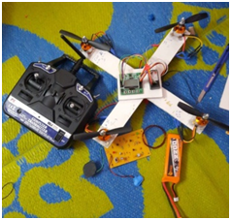**Stage 3**: In stage 3, we took the battery and power distribution board. The two are fixed to the frame with help of the glue and tape.

**Stage 4**: Setting up flight controller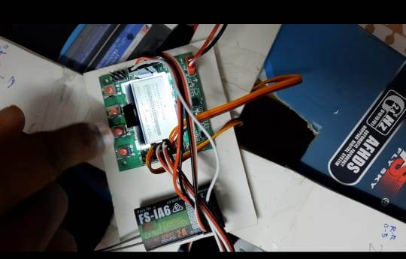. We used a flight controller for setting up the throttle, elevator, rudder and also acceleration calibration.

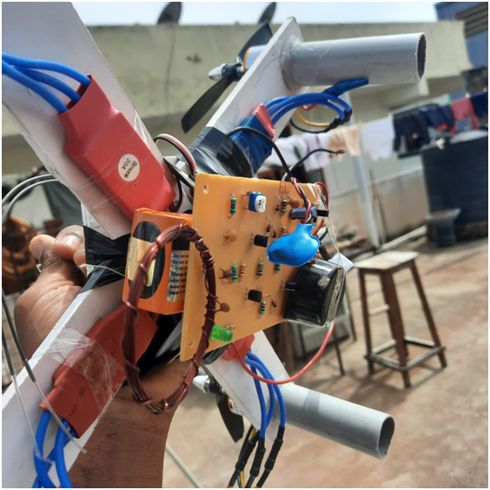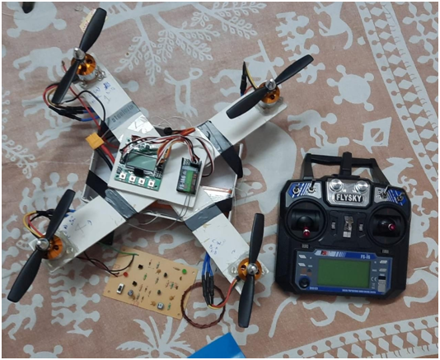**Stage 5**: In stage 5 the drone is ready to fly. At this stage the metal detector is fixed to the beneath the drone that to identify the landmines on the ground.

**CHAPTER 9**

**RESULTS**

Drone technology could be the key to clearing minefields around the world. Our project mainly focus on the detection of landmines and also building drone that costs less compared to others.

Firstly, we fabricated the Quadcopter drone and done all the setup, carried out the flight test for the drone. The drone has range from 0.1m to 1m. After the flight test we have assembled the metal detector to the drone. Our main aim is to save the lives of the people who are risking their lives in detecting the landmines.

We have placed two objects: tin sheet and cutting plier on the ground. Then we have run the test for testing the accuracy of the metal detector with varying altitude. The drone has covered the area where the objects where placed with the speed of 0.5m/s. First we have placed the objects on the ground and made the drone to fly at 2cm and the accuracy of metal detection is 99%. We observed that with increasing the altitude of the drone accuracy is been decreasing.

We formulated our test results in the table given below. This table establishes a relationship between the altitude and the accuracy of detecting the landmine. This shows results of 10 tests carried when the metal objects are placed on the ground and the drone is hovered on it.

|  |  |  |
| --- | --- | --- |
| **S.no** | **Altitude** | **Accuracy** |
| 1 | 2 cm | 99% |
| 2 | 2.5 | 95% |
| 3 | 3 | 90% |
| 4 | 5 | 85% |
| 5 | 7 | 80% |
| 6 | 9 | 75% |
| 7 | 10 | 70% |
| 8 | 11 | 70% |
| 9 | 12 | 60% |
| 10 | 15 | 50% |

**TABLE-1 :** Accuracy of metal detector with varying altitude when parts not buried.

We plotted a line graph for the above table where the altitude is taken along x-axis and the accuracy rate (in percentage) is taken along the y-axis. We can observe that when the distance between the detector the specimen increases, there is significant decrease in the probability in detection of the landmine.

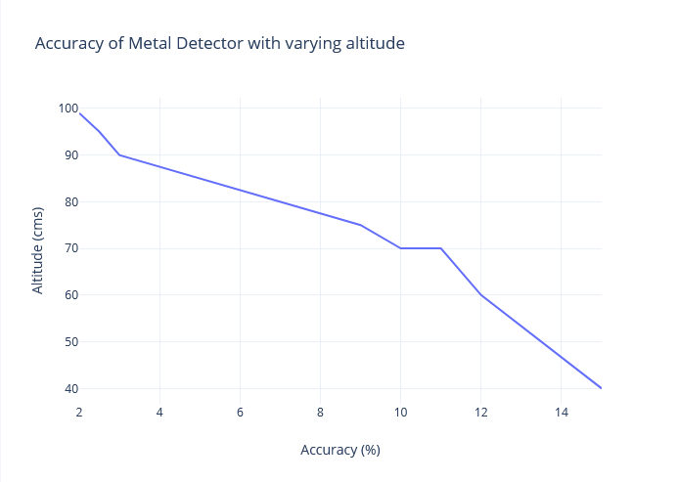

**Fig 9.1 Graph obtained from our test results**

In the second case of our examination, we buried some of our metal specimens partially under the ground for testing the detection of partially buried landmines. We formulated our results in the below table.

|  |  |  |
| --- | --- | --- |
| **S.no** | **Altitude** | **Accuracy** |
| 1 | 2 cm | Good |
| 2 | 3 cm | Moderate |
| 3 | 4 cm | Normal |
| 4 | 5 cm | Poor |

**TABLE-2 :**  Accuracy of metal detector with varying altitude when

partially buried.

From the above results, we incurred that when when the drone is flying at low altitudes, it is able to detect the landmine accurately. We observed that the metal detection is slightly less functional when compared to the objects placed on the ground.

Finally we can conclude that the Developed drone eliminates the risk of life threats to militants and reduce the traditional trial and error method of detection of the landmines. It is also provides greater range and increases the efficiency detecting landmines.

**9.1 Fabrication - Videos**

<https://drive.google.com/drive/folders/17T8fNktS7Xox1iKYspdkV_cCAAREv4dD>

**Chapter 10**

**Conclusion**

In this work we have proposed an implementation of a light weight drone for identification of landmines. We have presented the experimental setup and the results which point to a successful model of our proposed work.

It has been experimentally demonstrated that a low cost UAV such as quadcopter drone can be used as an accurate complement tool for detection of landmine tasks in rough scenarios.

We have run tests outdoor for landmine detection. We have tested our drone under Two parameters: altitude at which the drone flies and the accuracy of the metal detector. Based on observations we performed, we conclude that the drone we fabricated performs with a high percentage of accuracy when the drone hovers at a range of 5cm from the ground and also ensures a precise detection when the drone flies at a speed of 0.5m/s.

The designed drone for landmine detection is a cost effective material, which is an added advantage.

Finally, the drone projected an accuracy for the detection when the drone changes its position with respect to the object. In all the tests, the percentage of detection was higher than 80% when flying at 7 cm of altitude at a speed of 1ms-1. We have tested our system by measuring the average percentage of landmines detection in outdoor scenarios under three parameters: flight altitude, flight speed and visibility of the object. Based on the experimental results, we have determined that an altitude of 1m enables higher precision during the detection. At 5cm of altitude (partially buried object) the drone featured a 33.3% of detection flying at 1 ms-1.

Current and upcoming work is oriented towards the geo-localization of the detected landmines into a map by means of image mosaicing techniques.

**References**

* UAV for Landmine Detection Using SDR-Based GPR Technology, By Manuel Ricardo Pérez Cerquera, Julian David Colorado Montaño and Iván Mondragón Submitted: October 31st 2016Reviewed: May 12th 2017Published: December 20th 2017, DOI: 10.5772/intechopen.69738
* Design and Development of Heavy Drone for Fire Fighting Operation, <https://www.ijert.org/design-and-development-of-heavy-drone-for-fire-fighting-operation>
* Drone for good: How drones coupled with AI Have the potential to Rid the world of dangerous landmines by Zacc Dukowitz,https://avcoach.com/drones-landmines
* Review on Application of Drone Systems in Precision Agriculture, <https://www.sciencedirect.com/science/article/pii/S1877050918310081>
* <https://www.instructables.com/Simple-metal-detector/>
* Air Drones for Explosive Landmines Detection Authors Authors and affiliation C. CastiblancoEmail author, J. Rodriguez. Mondragon. Parra, Colorado C. Castiblan 1Email author , J. Rodriguez, I. Mondrago,C. Para,J. Colorada School of EngineeringPontificia Universidad Javeriana Bogota Colombia Conference paper.
* R.Siegel, “Landmine Detection”. IEEE Instrumentation And Measurment Magazine, Vol 5 Issue 4, 10th Dec 2002 , pp.22-28.
* Reza Abbaspour, “Design and Implementation of Multi-sensored Based Autonomous Minesweeping Robot” , 2010 IEEE International Congress on Ultramodern Telecommunication And Control systems and Workshops.
* Waqar Farooq, Nehal Butt, Sameed Shukat, Nouman Ali Baig, Sheikh Muhammad Ahmed. “Wirelessly Controlled Mines Detection Robot”, IEEE 2016 International Conference on Interlligent Systems Engineering pp.55-62.
* Seong Pal Kang, Junho Choi, Seung Beum Suh, Sungchul Kang, “Design of Mine Detection Robot for Korean Mine Field”, 2010 IEEE workshop on Advanced Robotics and its Social Impacts pp 53-56.
* Ryan Prins, Mahmut Kandemir, “Time Constrained Optimization of Multi-AUV Cooperative Mine Detection”, OCEANS 2008,pp.1-13.
* Alaa Khamis, “Mine Field Mapping Using Distributed Mobile Sensors”, 2016 Inrenational Conference on Robotics And Automation For Humanitarian Applications(RAHA).
* <https://www.dronezon.com/learn-about-drones-quadcopters/what-is-drone-technology-or-how-does-drone-technology-work/>
* <https://www.researchgate.net/figure/Offline-Model-Characterization_fig2_330477358>
* <https://www.wired.com/2017/05/the-physics-of-drones/>
* <https://homepages.abdn.ac.uk/nph120/meteo/DroneFlight.pdf>